Advanced Engineering Mathematics, by Erwin Kreyszig 10th. Ed.

**Problem Set 6.5**

No. 1



No. 2

No. 3





No. 4













No. 5





No. 6





No. 7





No. 8



ℒ



 





No. 9



ℒ



 





No. 10



ℒ



 





No. 11



ℒ



 





No. 12



ℒ

 

 



No.13



ℒ ℒ



 





No. 14



ℒ



 





No.15

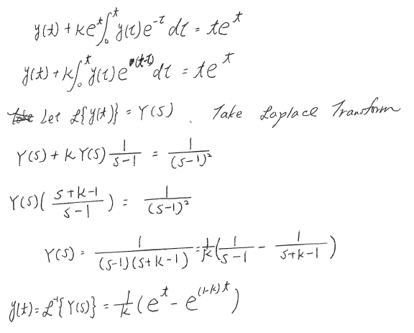

No.16

(a) Prove 





(b) Prove 







τ

t

P=t－τ

τ=t－p

p

t

0

(c) Prove 









(d) Let 



 Applying the mean value theorem for integrals at somebetween and

Let further 



Remark：The mean value theorem for integrals:

 forbetween and

(e) 

ℒ



 

ℒ-1ℒ-1



No.17

 ℒ-1 ℒ-1

ℒ-1



另解



ℒ-1

No.18

 ℒ-1

ℒ-1



Or using the First shift theorem ℒ-1

No.19

 ℒ-1 ℒ-1

ℒ-1











No.20

 Find ℒ-1

1. ℒ-1 ℒ-1







2. 

No.21

 ℒ-1

ℒ-1ℒ-1

ℒ-1

















另解



ℒ-1

No.22

 Find ℒ-1

1. ℒ-1 ℒ-1

 





2. 

No.23

 ℒ-1 ℒ-1ℒ-1

ℒ-1



Or ℒ-1



No.24

 Find ℒ-1

1. ℒ-1  ℒ-1 













2. 

No.25

 ℒ-1 ℒ-1

ℒ-1











No.26

